Spring 2014 Agriscience Essay Midterm Exam by C. Kohn
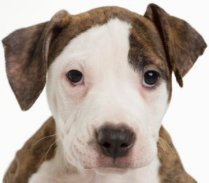
Name: Hour Date: Score: + ✓ -
Question 1: A puppy is born with a mutation that changes the amino acid sequence and the shape of the protein that breaks down starch.
Part 1) Explain how a mutation in this puppy’s DNA would affect its a) DNA, b) transcription, c) translation, d) protein folding, and e) protein function.

Part 2) The phenotype of this particular dog is not described above. Describe how the mutation will affect this dog’s phenotype if a) the mutation were dominant; b) the mutation were recessive; c) the mutation were incompletely dominant.

Part 3) If this puppy grew up, mated with another dog, and had puppies of its own, how would the offspring be affected? Assume one parent is heterozygous for the mutation, and the other parent is homozygous recessive (has the mutation). Would all the puppies be affected? Or would only some be affected? Could none be affected? What is most likely?

Name: Hour Date: Score: + ✓ -
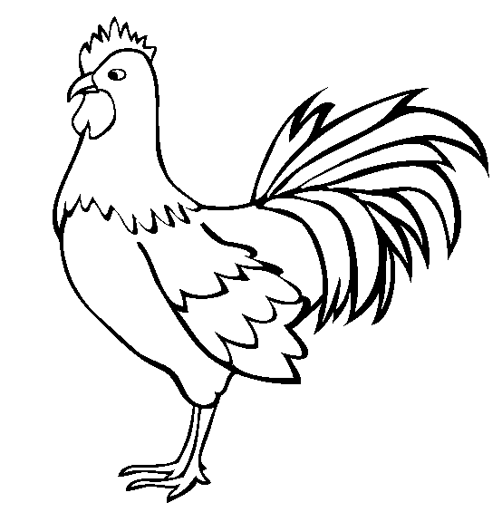
Question 2: In a breed of chickens called Wolverrinnes, color has an epistatic relationship. These chickens can either be red, orange, or yellow. A chicken will be red if they are RR or Rr. A chicken will be orange or yellow if they are rr _ _. While red (RR or Rr) is dominant to both yellow or orange, orange (rrGg or rrGG) is dominant to yellow (rrgg). To summarize
Red: RR_ _ or Rr _ _
Orange: rrGg or rrGG
Yellow: rrgg
Chicken A with genotype RrGg is crossed with Chicken B with genotype rrgg. Use this information to answer the questions below.
- What are the phenotypes of Chicken A and Chicken B?
- After showing your work in the dihybrid square below, state below how many offspring out of 16 would be red, how many would be orange, and how many would be yellow (assuming all predicted ratios are followed).

