Graphing in Microsoft Excel (use w/ http://bit.ly/vostokdata)
- Go to Mr. Kohn’s website. Under “This Week’s Assignments”, find the Vostok Lab link and click on it.
- When it asks if you’d like to save or open, click “Save”.
- Save your file under the R:Drive, Agriscience, 2013 2nd-5th Hour Natural Resources.
Name this file as “Vostok Your Last Name”
  - It may ask if you want to enable saving or enable editing. Click Yes for both.
- The file should now open and you should see 7 columns of data beginning with “depth m” in column A.
- Highlight all of column A by clicking on the “A” (click on the ‘A’ button above the column).
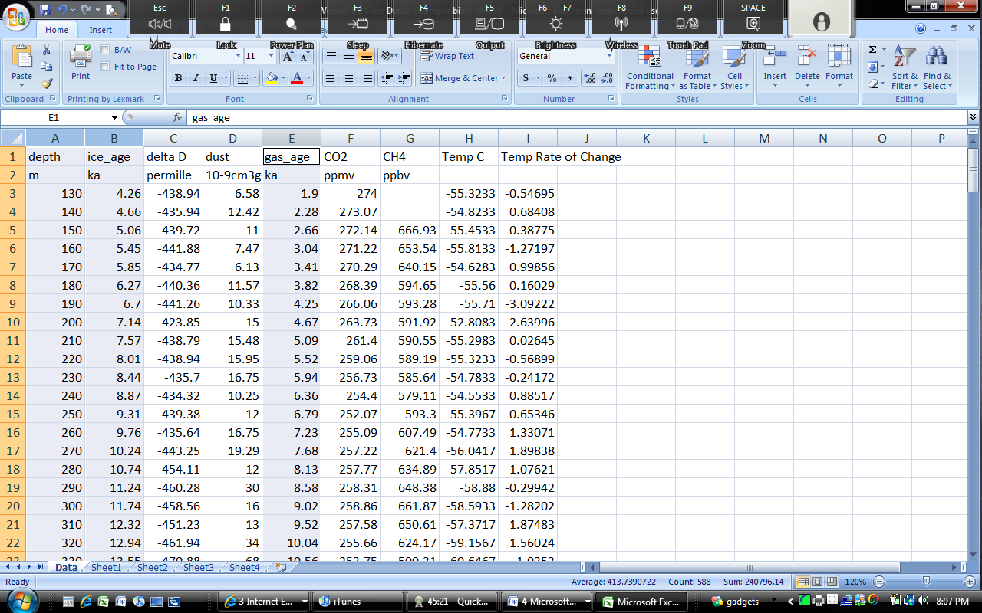
- While holding “CTRL” on your keyboard, select the “ice_age ka” and “gas_age ka” columns (columns B and E) so that all three are highlighted like column A. Make sure you get the entire column (and not just one cell)!
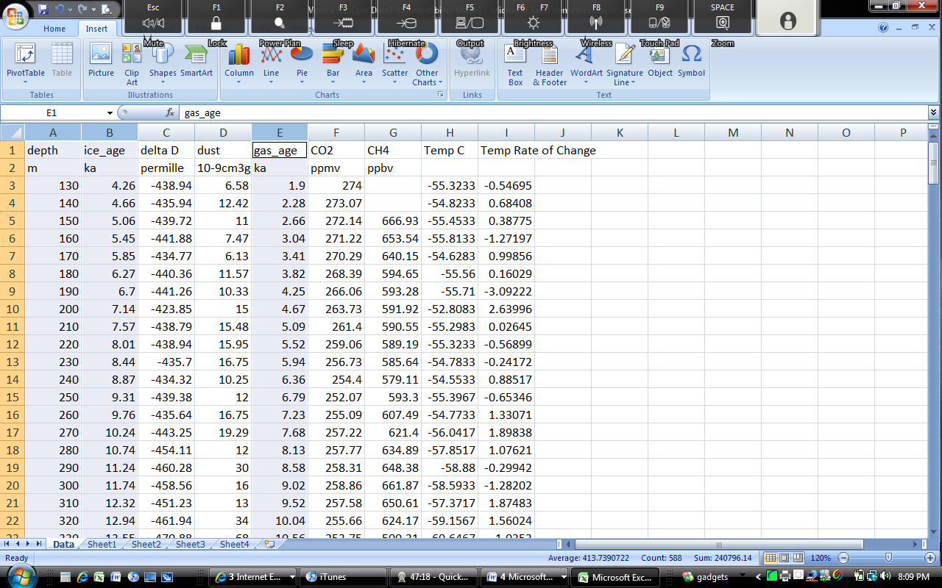
- On the menu bar, select “Insert”. Above your data, you will see, from left to right, options for inserting pictures, clip art, shapes, smart art, and graphs where your font options used to be.

- From this menu, select “Scatter”. Select the bottom option (Scatter with Straight Lines) from the Scatter Chart menu.
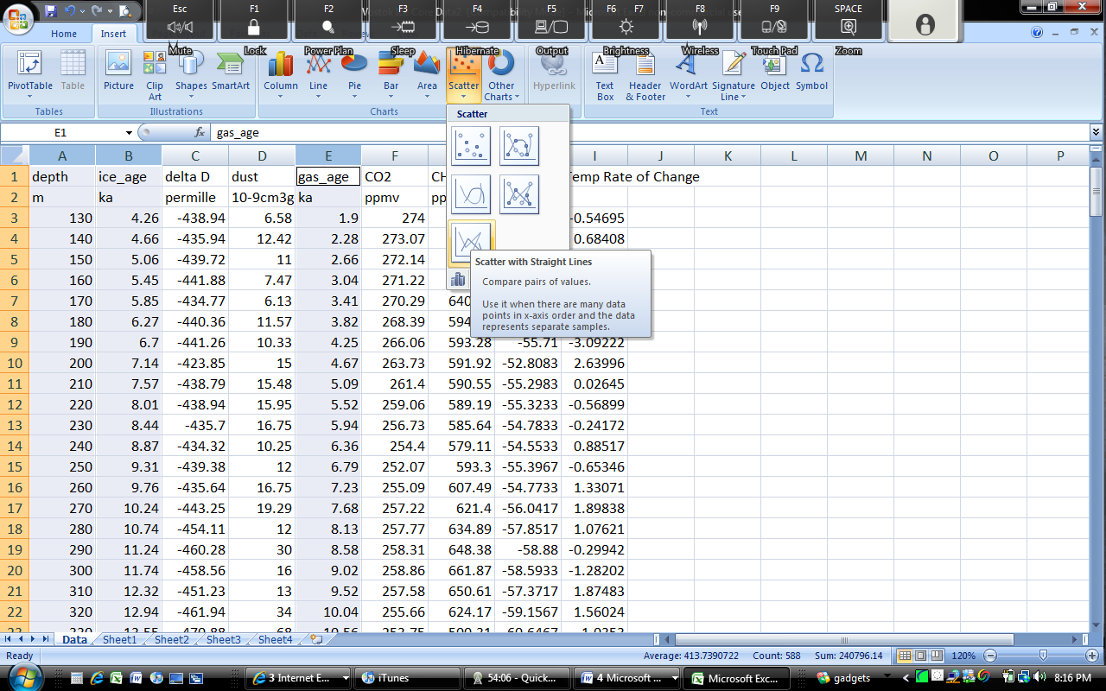
- A graph like the one below should appear (if not, click “Undo” and go back to step 5).
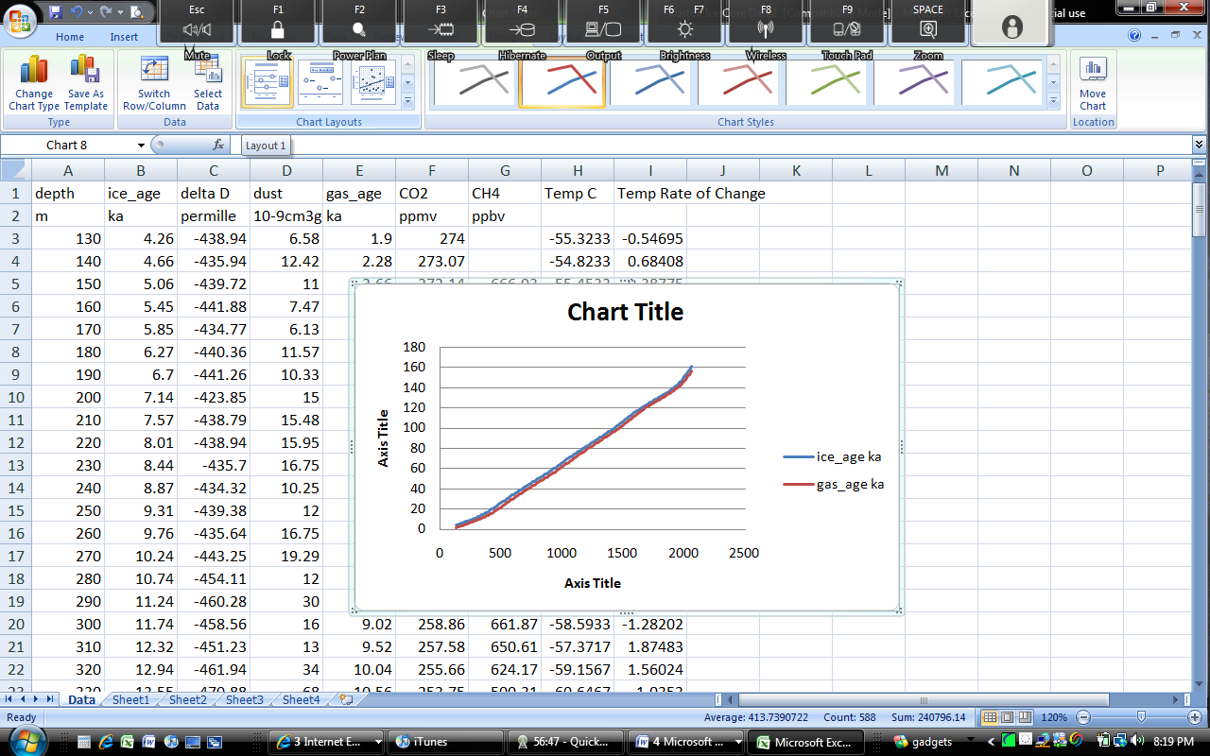
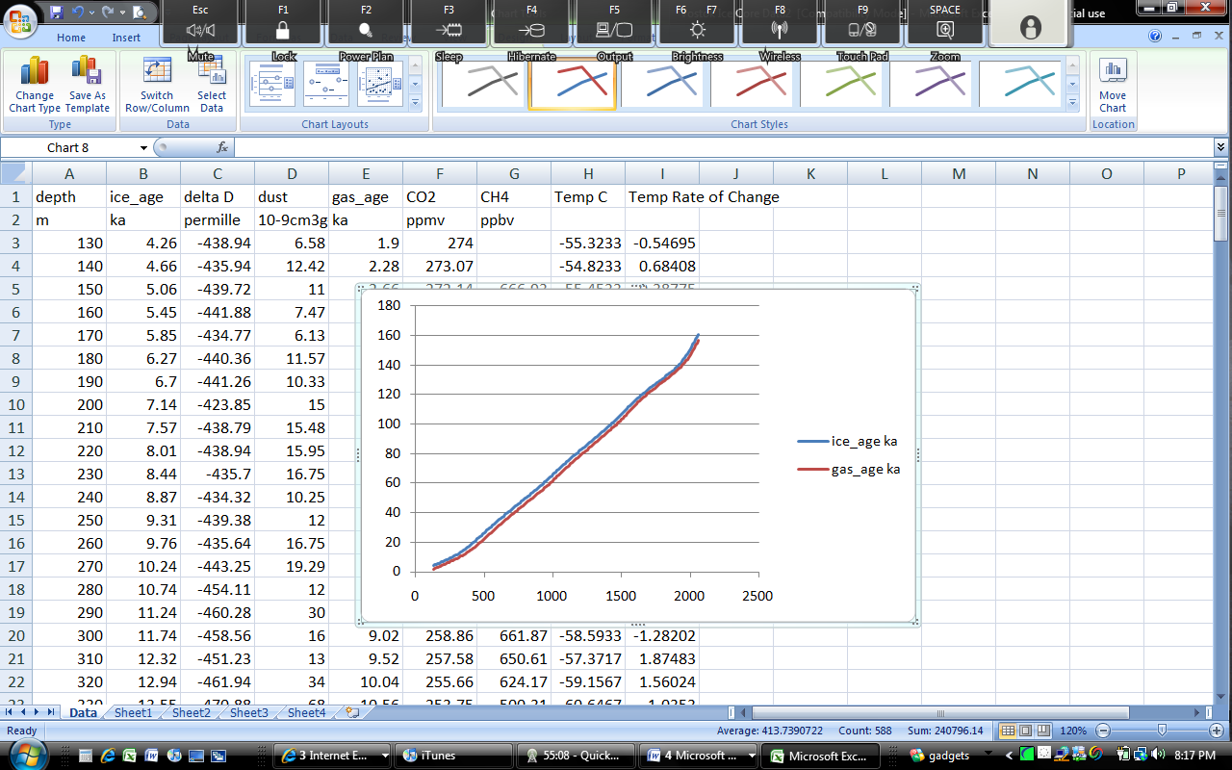
- From the “Chart Layouts” section in the menu bar (below “Formulas” on the menu bar), select the first option (Layout 1). Your graph should change to what you see below.

- Double click on “Chart Title” and replace it by typing “Ice Age and Gas Age as a Function of Depth”.
  - Replace “Axis Title” below the graph with “Ice Depth”.
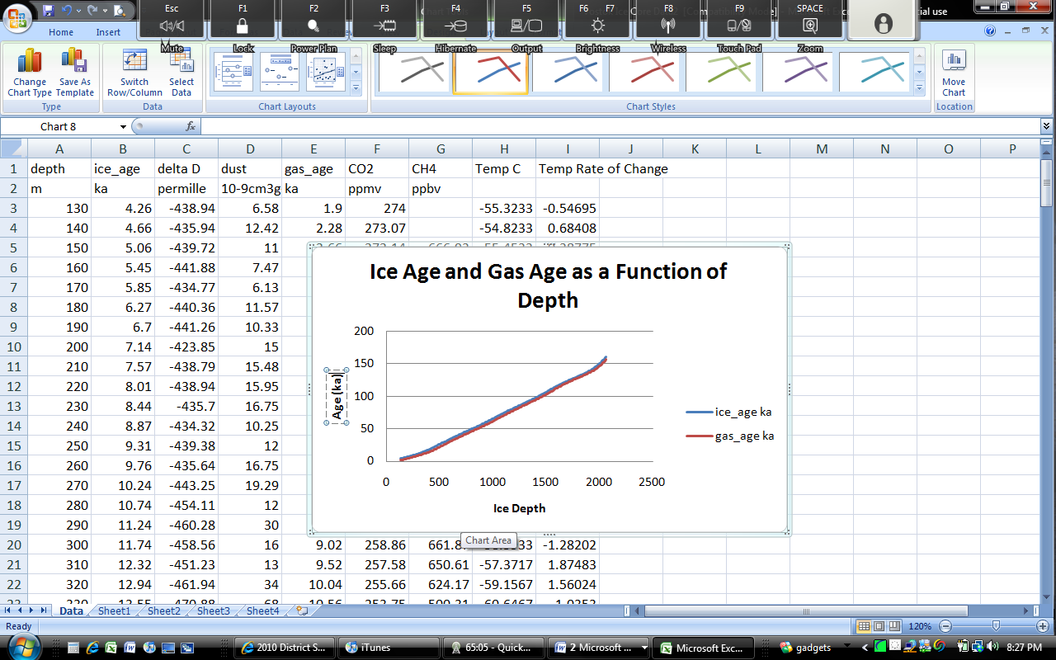
  - Replace “Chart Title” on the left side with “Age (ka)” (ka is kiloanum, or 1000 years)
- You’ve made a graph! Click and drag to the side where it is out of the way. Save your work (make sure you saved to the R Drive! This is where I will check when I do my grading.). You can save by holding both Ctrl and “S”.
- Next we will determine what the temperature was each year. We can determine temperature by determining how much Deuterium is trapped in each air bubble. Deuterium is a heavy form of hydrogen. The more of it in the air, the warmer the air was at that particular time.
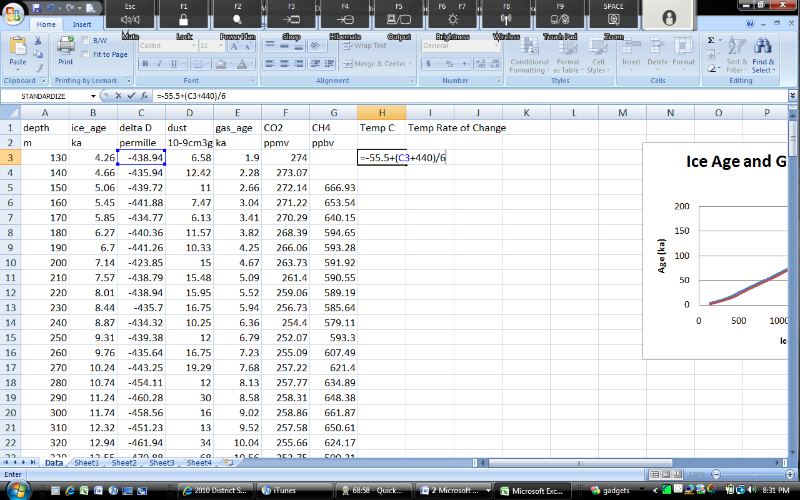
- Under the “Temp C” Column (Column H), type (or copy and paste) the entire following formula in Box H3:
=-55.5+(C3+440)/6
- Hit enter. You should now see -55.3233 in Box H3. This means in that particular year, the average temperature was -55 degrees Celsius. Keep in mind, this is Antarctica.
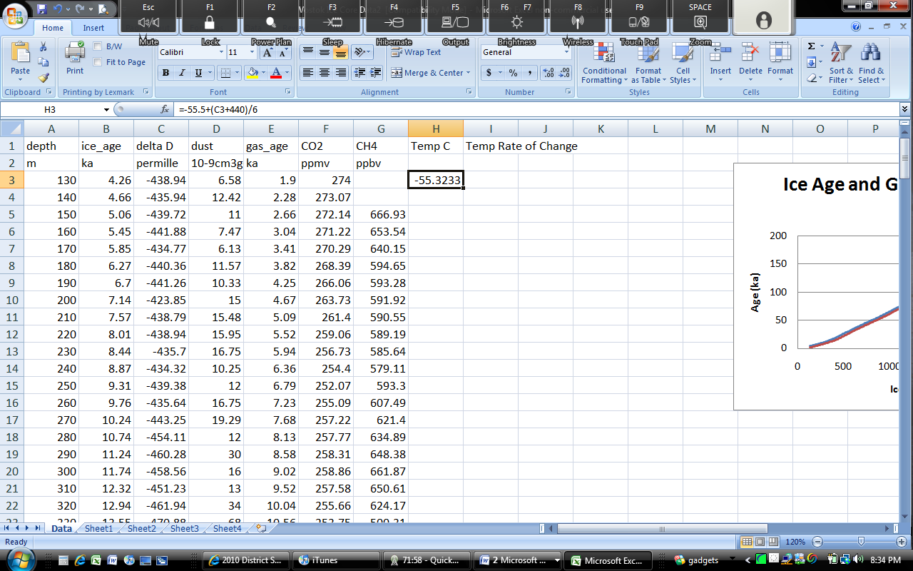
- Copying and pasting this into all 190 boxes is one option. Personally, I prefer a quicker method – let’s format the entire column with that entire formula in one single action. Select Cell H3. Center your cursor over the lower right corner of the cell where you see a small black box. Your cursor should turn from a white cross into a black cross.
- When your white cross turns into a black cross, click and hold your cursor. While holding your mouse button, drag your cursor all the way to the final line and then release the cursor.
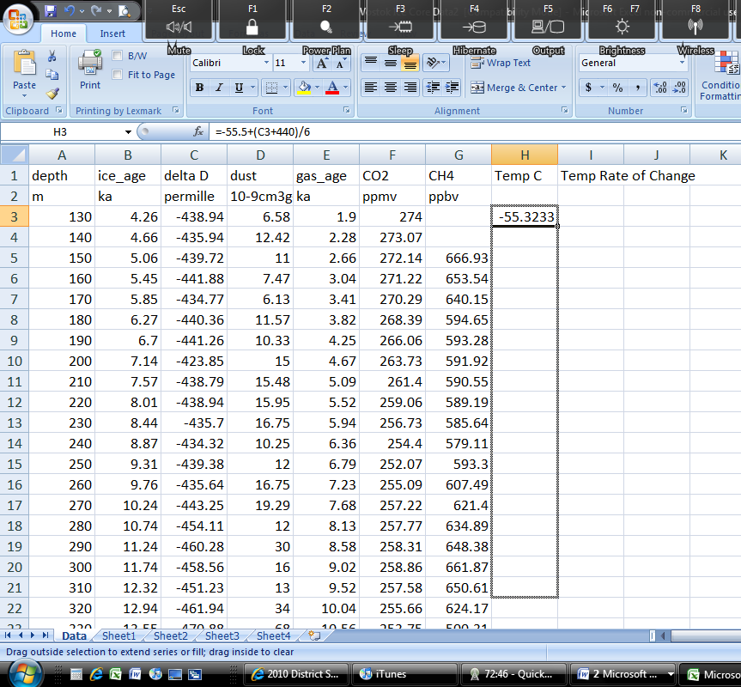
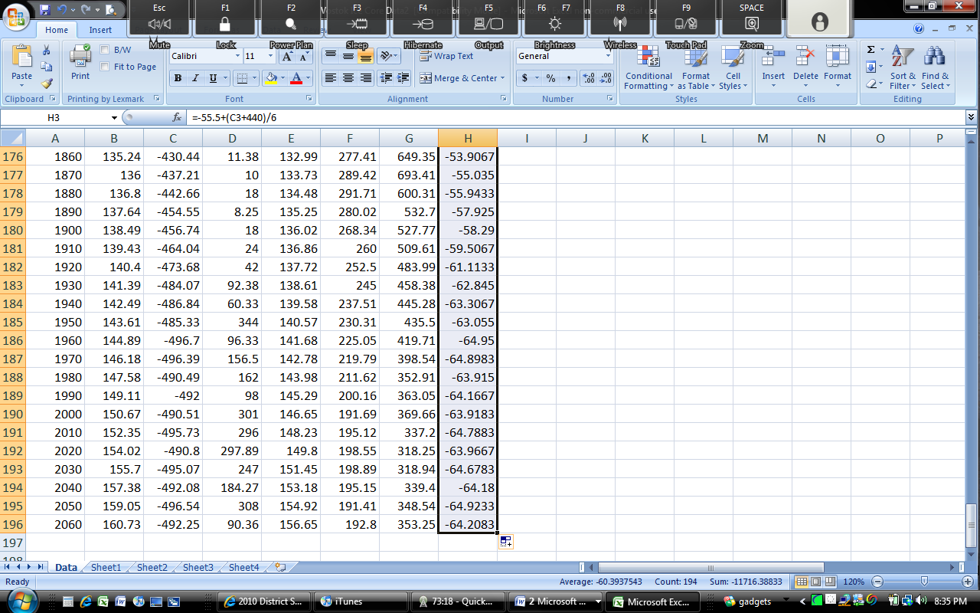
- You should see a whole column of numbers, each representing the temperature on average for that particular year based on the level of deuterium found on average in each layer of ice. Return to the top of the page. Save your work (again, you can hold both Ctrl and S at the same time, or save it using the menu bar).
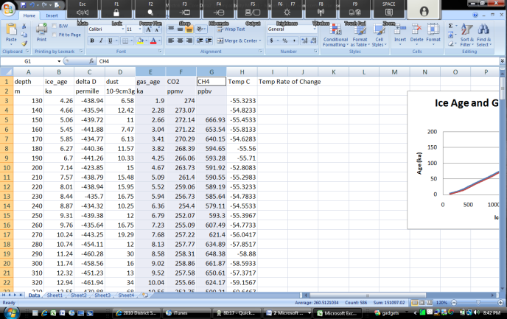
- We’ll now create graphs showing the fluctuations of CO2 and Methane over time. Select the “gas_age” column (Column E), hold CTRL and select the “CO2 ppmv” and “CH4 ppbv” columns (Columns F and G).
Be sure that all three columns are selected at the same time!
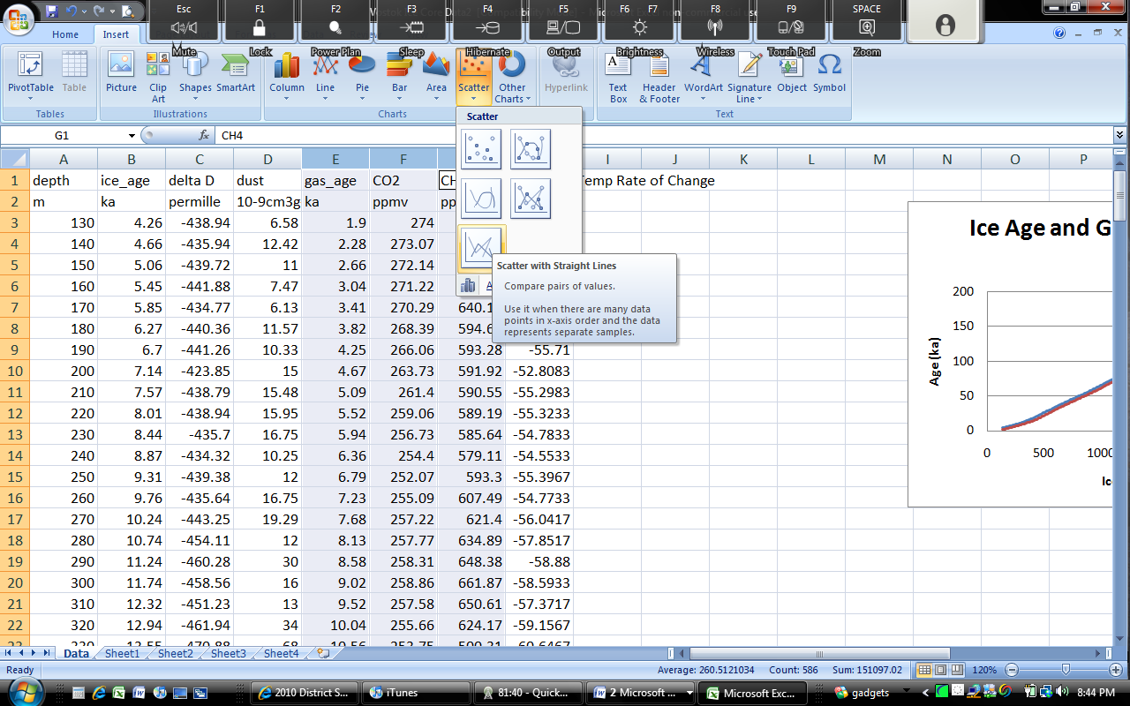
- On the menu bar, select “Insert”. Click Scatter and again select the bottom option (Scatter with straight lines).
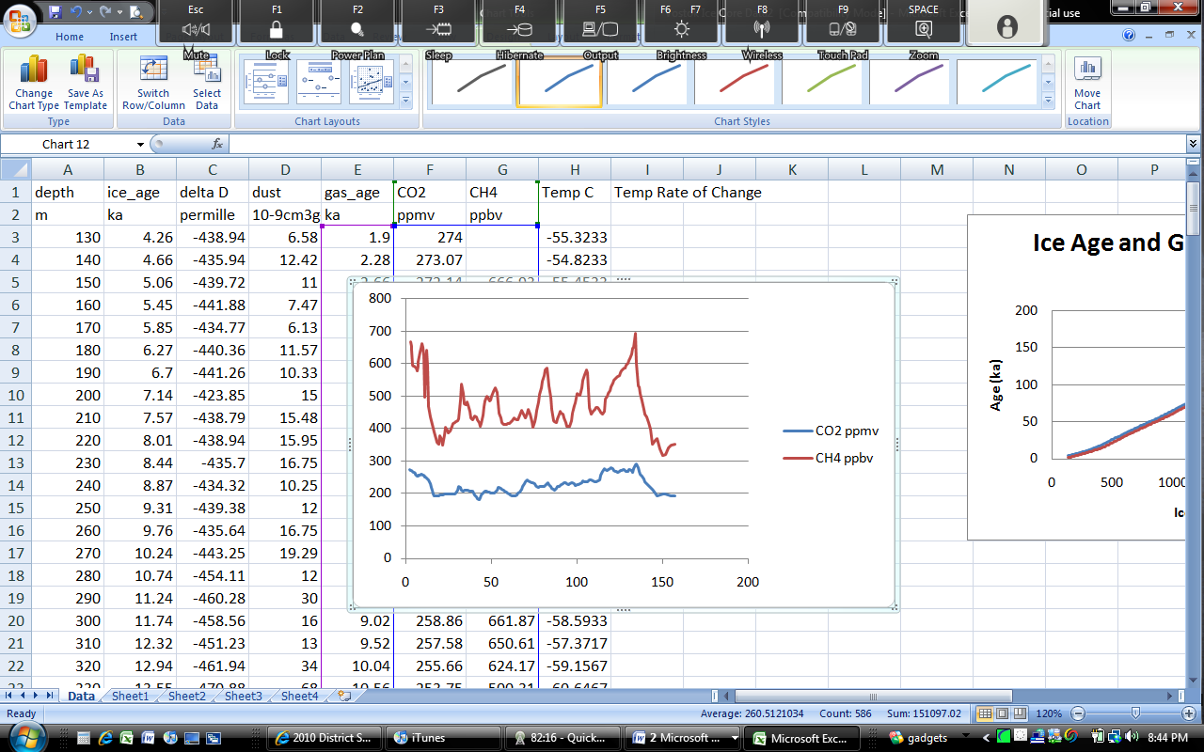
- The following graph should appear.
If yours does not look like this, hit Undo and try again!
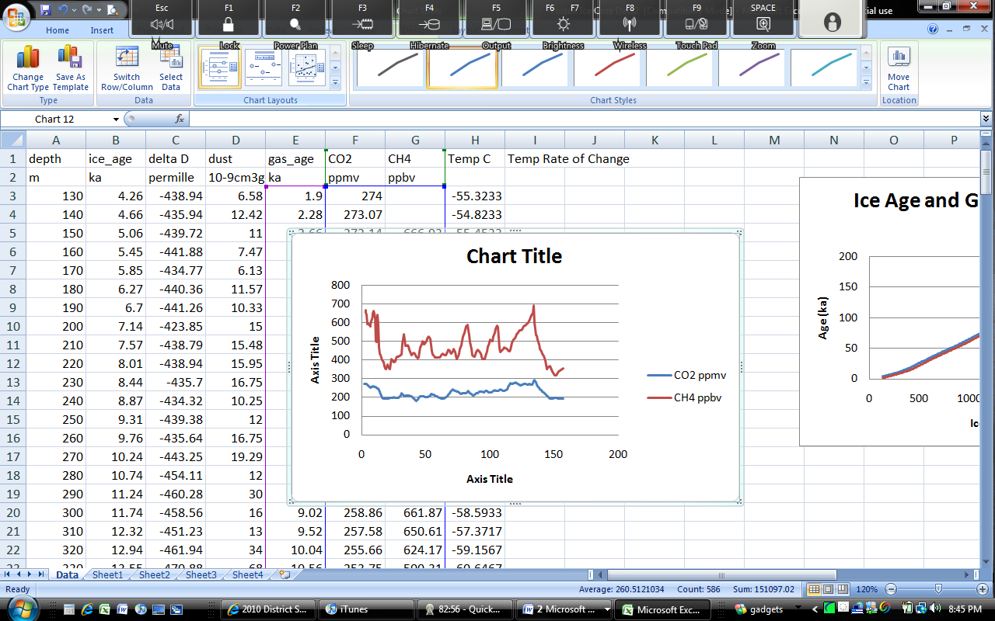
- On the “Chart Layouts” option, select the first option (see below)
- Name this graph “Pre-Industrial CO2 and Methane Concentrations”. Change the Axis Title below the graph to “Gas Age” and the Axis Title to the left to “Concentrations in PPM and PPB” Move your graph to the side.
- This is the average CO2 over the 160,000 year history of the Vostok Ice Core. This is the average prior to human interference due to the Industrial Revolution. How does this figure (in parts per million) compare to the current figure today of 375 ppm? The current CH4 concentration today is 1700 ppb (parts per billion).
  - This means that carbon dioxide is present at levels that are 25% higher than its greatest natural peak!
  - This means that methane today is 143% greater than it ever has been before.
- So at what levels, on average, should CO2 and CH4 exist in the atmosphere? Excel can figure that one out for us too. Below the CO2 and CH4 Columns (Columns F and G), paste the following formulas:
  - Below CO2 (Box F 197)paste this entire formula:
=AVERAGE(F1:F196)
  - Below CH4 (Box G 197), paste this entire formula:
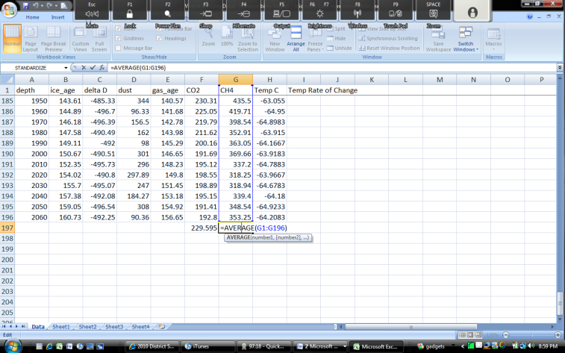
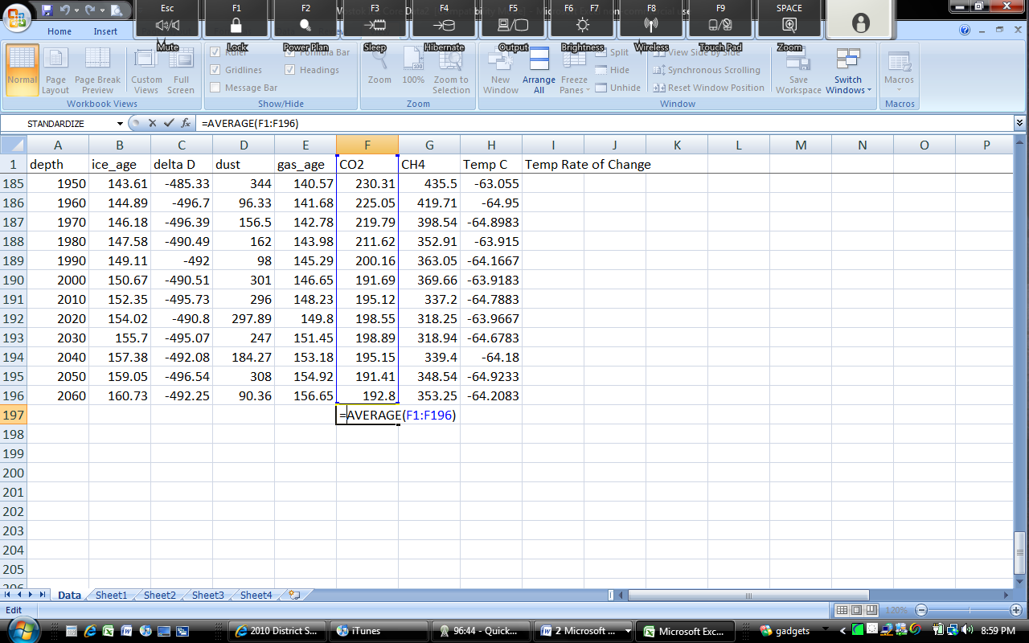
=AVERAGE(G1:G196)
- Return to the top of the page and save your work.
- Climate scientists are concerned with the rate of change as much as the total change. In other words, scientists are concerned that we are changing more rapidly every year. How has this affected the planet in the past? Excel can be used to determine this too!
- In Box I4 paste the following formula (make sure you’re not in Box I3!)
=(H3-H4)/(B3/B4)
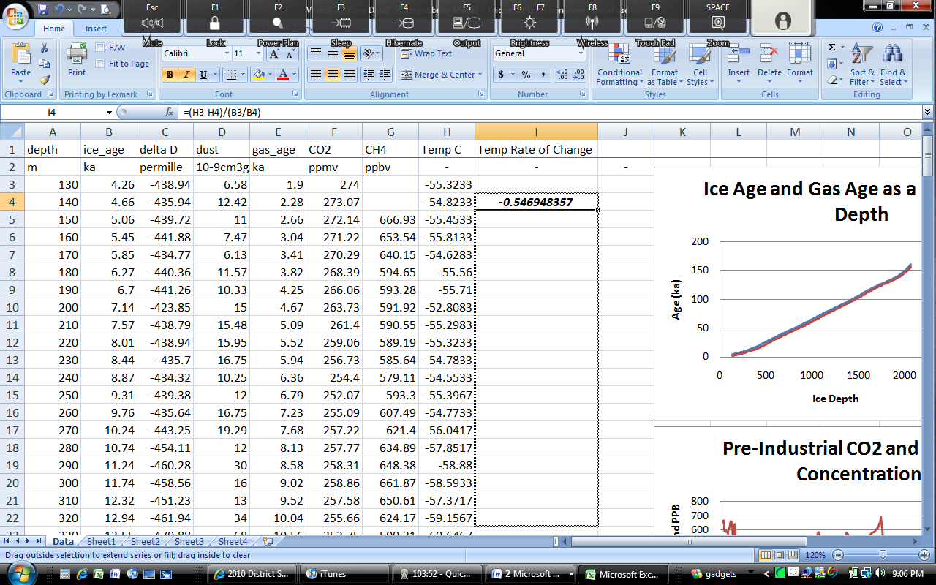
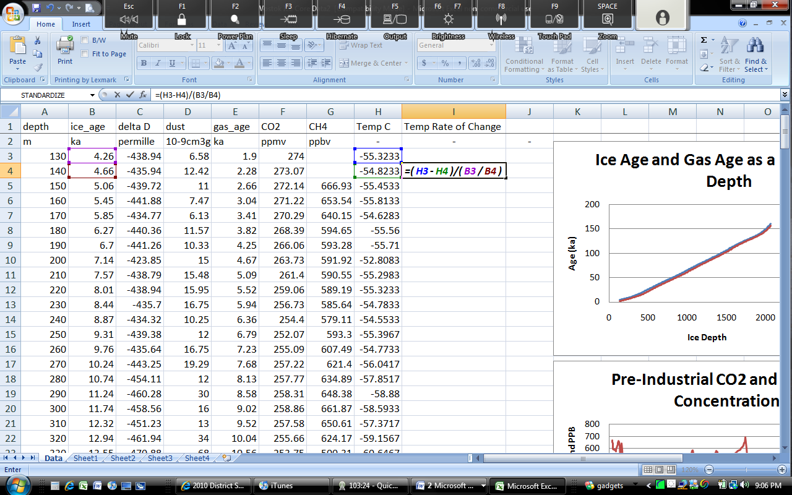
- Click on Box I4, and position your cursor over the lower right corner so that the white cross on your cursor becomes a black cross. Click, hold, and drag to the bottom.
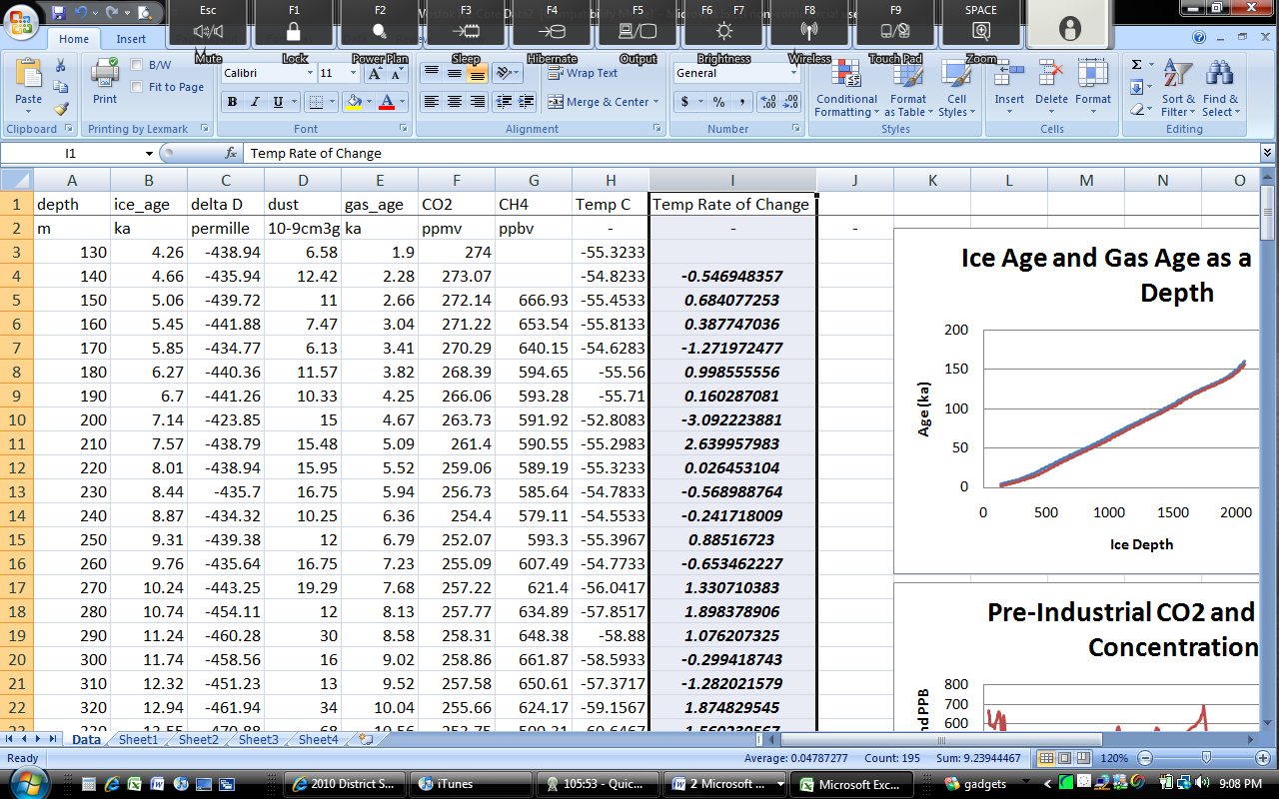
- When Your Temp Rate of Change Column (Column I) is complete filled, select the entire column by click on the “I” at the top of the column.
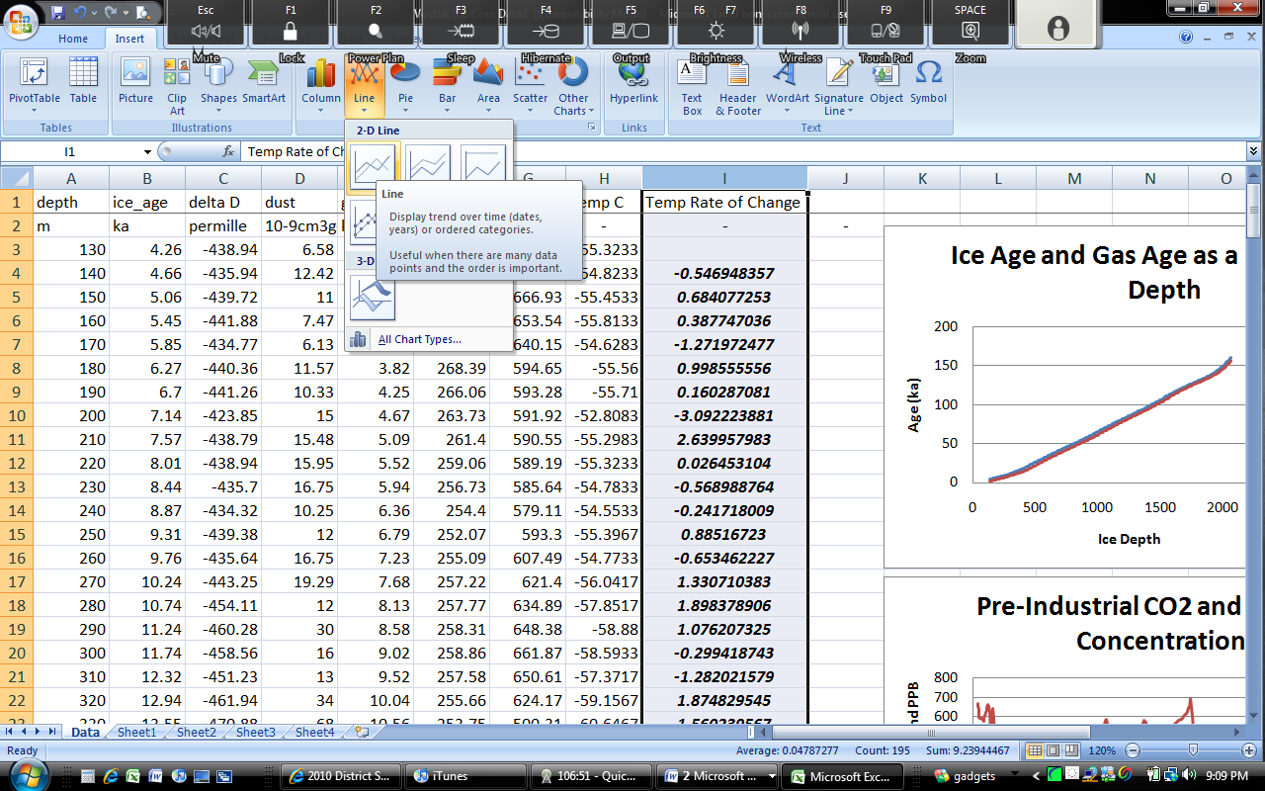
- On the menu bar, click “Insert”, click Line, and select the first Line Graph Option (Line)
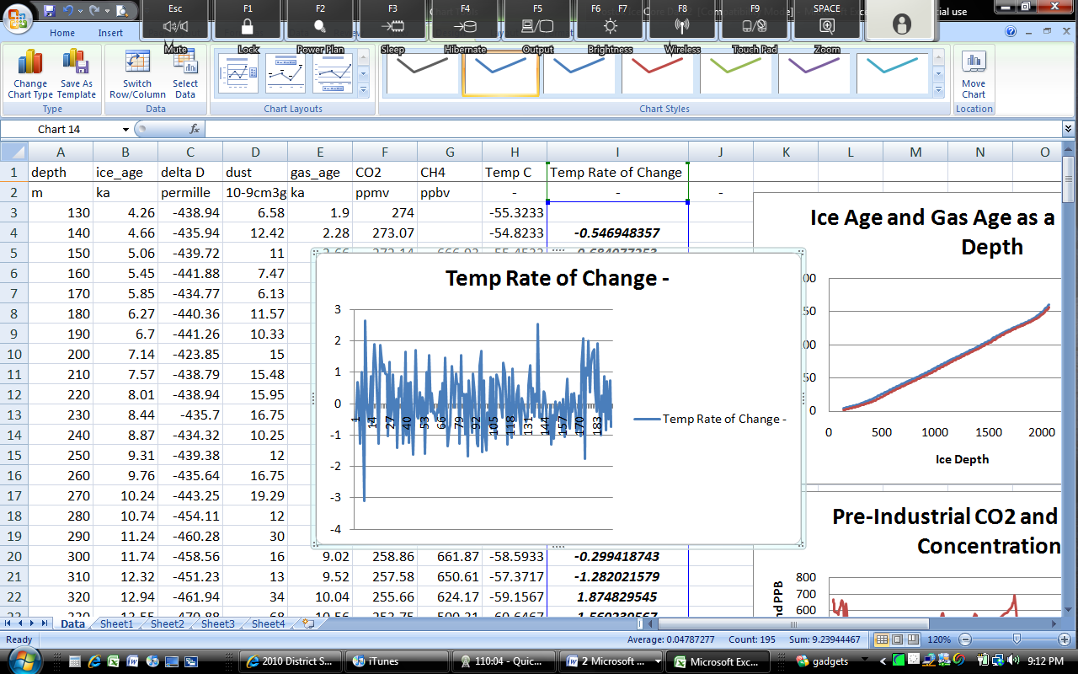
- When finished you should see a graph like this one below
- Each point on the horizontal (back and forth) axis is equal to 1000 years. As you can see, throughout geological history, we’ve only seen a rate of change of at very most 2 degrees every millennia Scientists are expecting the earth to warm by a minimum of 2 degrees and as much as 11 degrees by the end of this century.
  - In other words, we are looking at a temperature change on the magnitude of up to 4 times the maximum rate that has ever occurred within the history of this planet; i.e. this is not a natural cycle!
  - This is all expected to occur in a timeframe that is at most 1/10 what we see here and probably less.
  - All in all, this is the equivalent of a temperature change at a pace that will, at its minimum, occur at a rate 10 times faster than a “natural” change.
  - Will species be able to adapt? What do you know about the rate at which species can acquire adaptations? Is it fast or slow? What do you think will happen to living species when their habitat changes at a rate 10 times the normal rate?
  - The last major spike in temperature was a 2º increase over the course of 1000 years. What immediately followed in the next millennia?
    - Hint: it’s named after the State of Wisconsin; it was an age where there was a lot of ice.
- Drag your graph to the side and save your work. Read the short excerpt below and consider your work just now. Be prepared for a class discussion on this exercise and the short reading below.

Climate Change Predictions for the Midwest (2009)
By the end of this century, the Midwest could face more simmering Texas-style heat in summer, more Seattle-like downpours in other seasons and levels of some Great Lakes that are as much as 2 feet lower. Those are among the worst-case scenarios in a new study on climate change compiled by 13 federal agencies. Past reports have targeted the global effects of rising global-warming gases, but the latest report covers findings for the United States.

The 200-page report by the Global Climate Research Program synthesized a number of recent studies, many of which have already been made public. The study said average temperatures across the United States have risen by 2 degrees in the past five decades and could rise another 4 to 11 degrees by 2100. If the nation cuts global-warming gas emissions, the temperature increase will be at the low end; if not, it will be at the high end. Source: Michigan State University Libraries

“Sometimes, the world simply needs you to do the right thing.
If not you, who? If not now, when?”

