Water Testing Lab C. Kohn, Waterford WI
Group Names (first/last):
Date Due: end of class Why late? Score: + ✓ -
Directions: use a field sample of water and a water testing kit to complete the questions below.
+ =work that exceeds expectations (100%). ✓=work that meets expectations (80%)

- Visually observe your first sample of water. Based on your visual observations, give this sample a score between 1 (poorest) and 5 (pristine):
Score: Defend why you assigned this score:
- Perform a test related to the nitrogen or nitrate levels in the water (use the instructions provided by the kit).
What were the results of this test?
What does this indicate about the water quality in this sample?
Is this body of water at risk for eutrophication based on the nitrogen/nitrate levels?
Explain:
- Perform a test related to the phosphorus or phosphate levels in the water (use the instructions provided by the kit).
What were the results of this test?
What does this indicate about the water quality in this sample?
Is this body of water at risk for eutrophication based on the phosphorus/phosphate levels?
Explain:
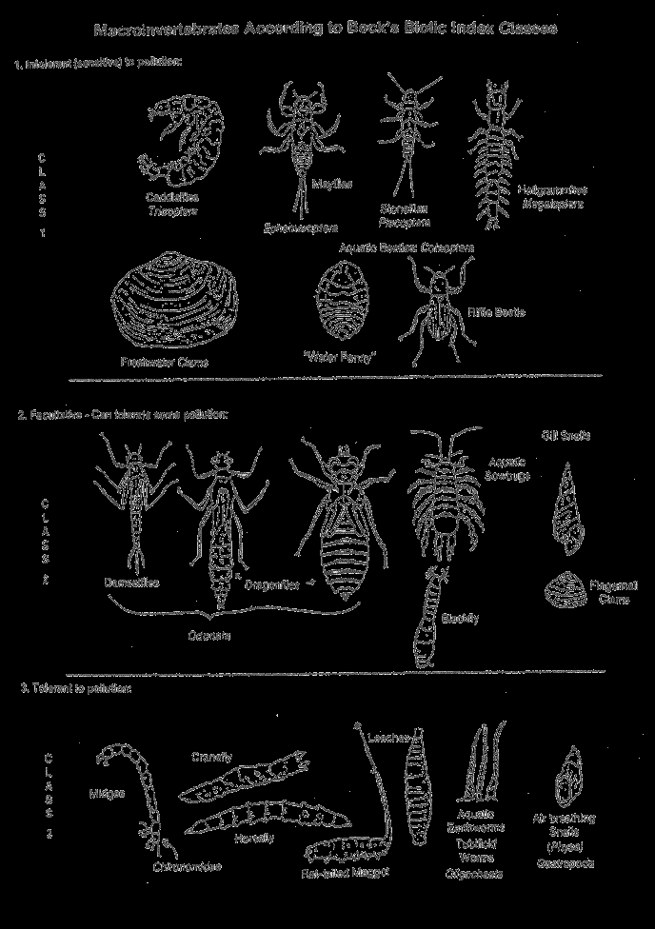
- Based on the results of the nitrogen/phosphorus levels in this water sample, what class of macroinvertebrates do you think would be most prevalent?
Class 1 Class 2 Class 3
Explain why you chose the answer you did above:

- Perform a test of heavy metals in this body of water.
What metal did you test?
What were the results of this test?
What problems, if any, do these results indicate could happen?
- Test the pH of this water. What were the results? Based on these results, do you
think that this sample of water has been affected by acid rain? Explain:
- Based on your test results, give this sample a score between 1 (poorest) and 5 (pristine):
Score: Defend why you assigned this score:

- Visually observe your second sample of water. Based on your visual observations, give this sample a score between 1 (poorest) and 5 (pristine):
Score: Defend why you assigned this score:
- Perform a test related to the nitrogen or nitrate levels in the water (use the instructions provided by the kit).
What were the results of this test?
What does this indicate about the water quality in this sample?
Is this body of water at risk for eutrophication based on the nitrogen/nitrate levels?
Explain:
- Perform a test related to the phosphorus or phosphate levels in the water (use the instructions provided by the kit).
What were the results of this test?
What does this indicate about the water quality in this sample?
Is this body of water at risk for eutrophication based on the phosphorus/phosphate levels?
Explain:
- Test the pH of this water. What were the results? Based on these results, do you
think that this sample of water has been affected by acid rain? Explain:

- Based on the results of the nitrogen/phosphorus levels in this water sample, what class of macroinvertebrates do you think would be most prevalent?
Class 1 Class 2 Class 3
Explain why you chose the answer you did above:

- Perform a test of heavy metals in this body of water.
What metal did you test?
What were the results of this test?
What problems, if any, do these results indicate could happen?
- Based on your test results, give this sample a score between 1 (poorest) and 5 (pristine):
Score: Defend why you assigned this score:
- Of the two samples of water, which comes from the healthier ecosystem? 1st Sample 2nd Sample
Explain why you chose your answer:

